Locking Features

Mechanically applied
Our self clinching nuts can be supplied with a mechanically applied locking feature. The feature is applied post production and can be applied with the required torque. The feature can be applied on nuts both in stainless and steel on threads up to an M10 and 3/8-16.

ND PATCH®
We can provide the ND Locking Patch to our self clinching fasteners, which provides a cost effective way, to prevent a mating part from becoming loose. The ND Locking Patch process does not physically distort the threads since the locking feature is provided by applying an engineered plastic directly on the threads of the fastener itself. The ND Locking Patch can be applied to both internal and external threads. ND Patch is normally applied 1-3 threads back from the end of the fastener to insure ease of starting and the normal coverage is approximately 4-6 threads. ND Patch does not require any drilling or milling of the part, thus retaining the structural integrity of the fastener. ND Patch meets and exceeds IFI specifications 124 & 524 as well as Military Spec MIL-DTL-18240F, Type P, for temperatures from -70°F(-57°C) up to +250°F(+121°C). ND Patch is also chemical resistant, and will not lose its shape when exposed to commercial solvents such as alcohol, gasoline, oil, caustic soda, jet fuel, etc. The ND Patch also saves time by reducing the need for retightening and has the ability to be fed through standard feeding systems.
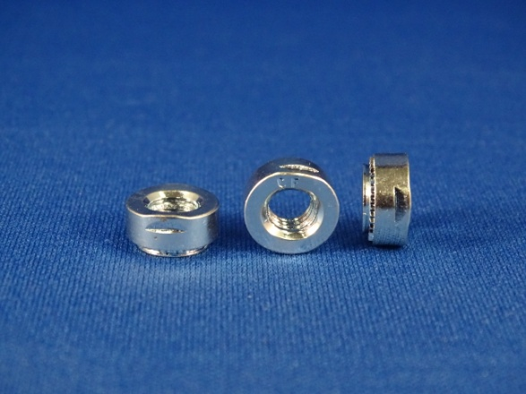
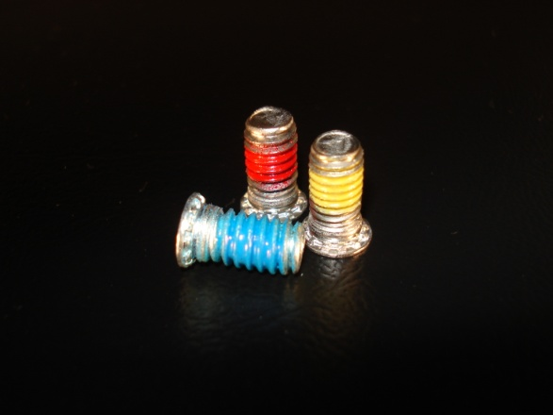
For more information on either one of these new services please contact your customer service rep.

